**Trade Tokens**

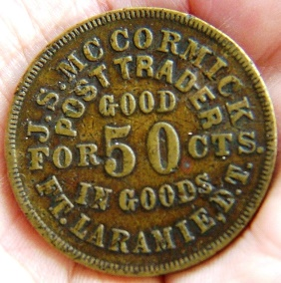Used from 17th to the 19th century in the British isle, most commonly issued by merchants to enable trading activity during times when money was limited by government. Effectively you could redeem goods in exchange for the token.

Most tokens indicated the name of the merchant or shop and the value of the token.

English civil war

* Ceased production on copper farthings
* Led to shortages of small change
* Prompted the issue of tokens

18th Century coin Shortage

* Royal mint almost ceased all production
* Tokens started to be produced
* Now machine made
* 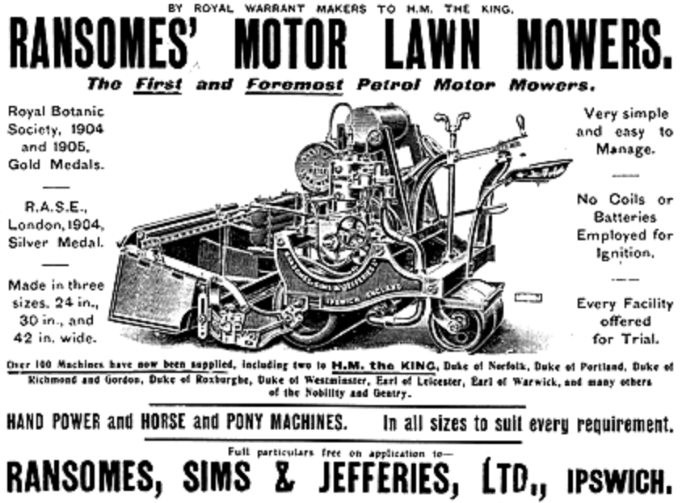Some were produced for advertising purpose

**Ransomes Lawnmower**

Ransomes, Sims and Jefferies were a major agricultural machinery maker producing

* Traction engine
* 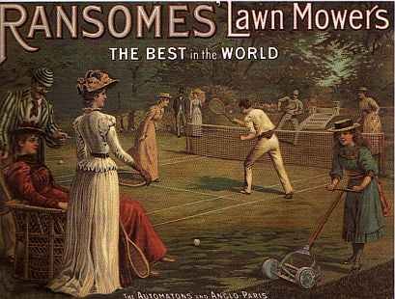Trolleybuses
* Ploughs
* Lawn mowers
* Combine harvesters

Started in 1753 in Norwich before moving to Ipswich in 1789

**Lyceum Theatre**

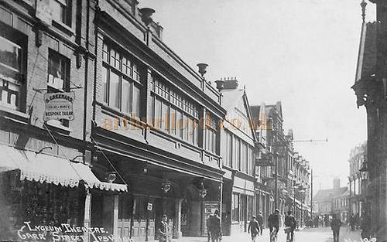Opened in 1891 and home to plays and drama but soon went over to variety including early film screenings.

After first world war it was taken over by Bostock circuit, who had taken over the Hippodrome Theatre in the town some years earlier.

Became full time cinema for a short time however reverted back to live theatre in the 1930’s. Closed in mid-1930 and converted to department store 1936. Remained store until 1980’s then demolished and became the Carr Street shopping precinct.

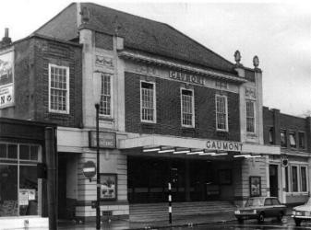**Gaumont Theatre**

The regent theatre was opened on the 4th of November 1929, exterior style is in the Georgian style, interior is a combination of Neo Classic and Art Deco

In 1955 it was renamed Gaumont, in 1987 the theatre was rebranded with the Odeon name. Both cinemas closed 20th March 1991 after being acquired by the borough Council so it could be restored to live theatre use. The theatre reopened with its original name of The Regent on 21st of September 1991.

**Alderton’s Cobbler**

Started business in 1853 on Brook Street, however in 1857 opened a larger premise 44 Butter Market. Thomas Alderton was a natural at boot making, particularly ladies footwear.

Alderton’s was the first shop in Ipswich to be internally illuminated by electricity.

Alderton’s traded for 140 years until a building fire in the building next door caused major damage and was destroyed.

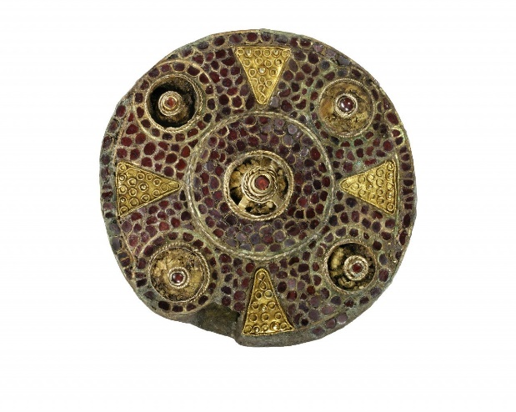

**Boss Hall Brooch**

Discovered in an Anglo-Saxon lady’s grave at Boss Hall in Sproughton, the grave is one of the richest graves ever discovered in Ipswich.

The Brooch was found in a special pouch that was placed on her chest, the brooch I made of gold and set with hundreds of garnets.

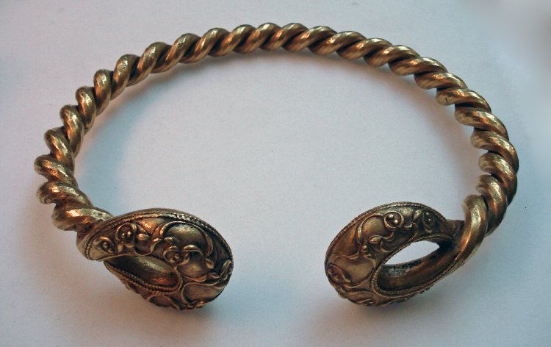**Ipswich Torcs**

Discovered during building work in Holcombe Crescent in 1968. Gold torc with loop terminals, the neck-ring consists of two fluted bars twisted together.

Made from Gold Alloy dating back to 150 BC – 50 BC associated with the iron age La Tene culture.

**Racecourse post and bell**

Ipswich Racecourse was on Nacton Heath, the post and bell once stood at the start/finish line. The earliest mention of an annual race in Ipswich was 1810, the last race meeting was 29th March 1911.

The area has since been developed into housing and a park.

**Saxon Ipswich Ware**

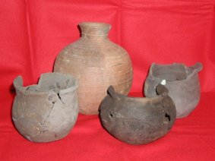Ipswich Ware was exclusively manufactured in Suffolk, within a few decades the Ipswich ware was the only pottery in use on sites anywhere in East Anglia.

* Manufacturing Tech More Advanced
* Finished on a turn-table and fired in kilns
* Different Forms of Pottery
* Far Greater Distribution compared to other English pottery type
* Ipswich ware found throughout eastern England
* Found as far as Oxfordshire